**PROJECT TOPIC: Twitter Sentimental Analysis**

**Group No. : 138**

**Project Group Members:**

1. Aman Singh (C-05/171500036)

**2.** Ayush Gupta (B-14/171500071)

**Project Supervisor:** Mr. Juginder Pal Singh, Assistant Professor

**About the Project:**

In this project we choose to try to classify tweets from Twitter into “positive” or “negative” sentiment by building a model based on probabilities. Twitter is a microblogging website where people can share their feelings quickly and spontaneously by sending a tweets limited by 140 characters. You can directly address a tweet to someone by adding the target sign “@” or participate to a topic by adding an hastag “#” to your tweet. Because of the usage of Twitter, it is a perfect source of data to determine the current overall opinion about anything. After classifying the tweets we will show the information in form of emotions.

**Motivation:**

This project was motivated by our desire to investigate the sentiment analysis field of machine learning since it allows to approach natural language processing which is a very hot topic actually. Following my previous experience where it was about classifying short music according to their emotion, I applied the same idea with tweets and try to figure out which is positive or negative.

**Project Planning:**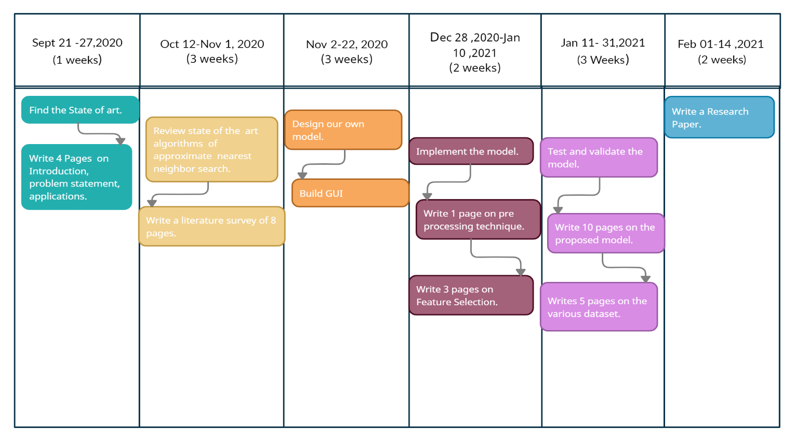

**Tools required:**

* **Hardware Requirements:**
* Processor (64 bit), Quad-core and above
* RAM (8 GB)
* Hard disk (100 GB)
* Graphical Processing Unit (min. 4 GB)
* **Software Requirements:**
* Windows 7/8/8.1/10
* Microsoft Visio
* Python (version 3.7 and above)
* MS Excel
* Spyder IDE

**Signature of Project Supervisor: _____________________**